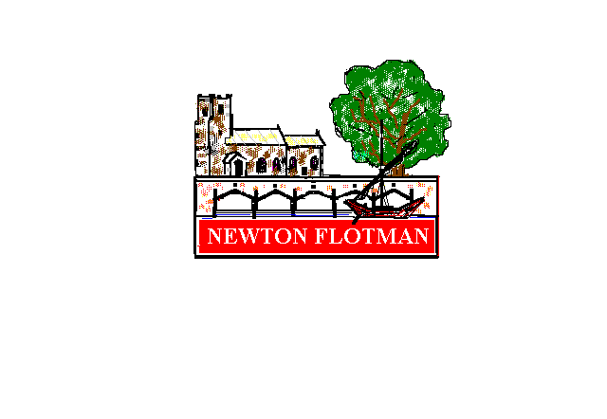

# Newton Flotman Parish Council

Tel 01508 447688

Email [clerk@newtonflotmanpc.co.uk](mailto:clerk@newtonflotmanpc.co.uk)

[www.newtonflotmanpc.co.uk](http://www.newtonflotmanpc.co.uk)

# Grant Application Form

For all not-for-profit groups and organisations meeting within the parish, and operating for the benefit of the residents of Newton Flotman.

Name of Group/Organisation

Registered Charity Number (if applicable)

Purpose of Group/Organisation

## Current Membership

| **Age Range** | **Under 5** | **5-12 yrs** | **13-19 yrs** | **20-54 yrs** | **55 +** | **Total Overall** | **Total from Newton Flotman** |
| --- | --- | --- | --- | --- | --- | --- | --- |
| Female |  |  |  |  |  |  |  |
| Male |  |  |  |  |  |  |  |

| **Current Officers** | **Name** | **Address** | **Tel. No** |
| --- | --- | --- | --- |
| Chairman |  |  |  |
| Secretary |  |  |  |
| Treasurer |  |  |  |

Sources of Regular Funding

Subject of Application

Other Financial Sources being pursued

## Documents to be sent with application:

* copies of two written quotations / estimates for all costs involved

For established groups:

* latest set of accounts and balance sheet
* details of current financial position

or for new groups:

* a planned budget

## Project details and reason for application:

Total Cost of Project £

Amount requested from Parish Council £

Declaration: the above information is submitted to the Parish Council and is correct to the best of my / our knowledge.

Signature of Applicant:

Printed Name:

Position in Organisation:

Date:

Please note that the Parish Council likes to meet with all applicants, the Parish Clerk will let you know at which meeting this application will be considered.

Please send this completed form, together with supporting information to the Parish Clerk: [clerk@newtonflotmanpc.co.uk](mailto:clerk@newtonflotmanpc.co.uk). By 31st October 2023

## Data Protection

The data contained on this form will be retained for the purposes of this grant and, if you are successful, within the Council’s accounts for the required seven years. The data is held securely and will not be shared or be used for any other purpose.

As a data subject you have detailed rights including: right of access to your own personal data, right of correction, erasure and to object to processing and the right to lodge a complaint with the Information Commissioner (the ICO).

More information regarding how the Parish Council handles data can be found in its [privacy statement](https://79c8df62-0151-48ad-9096-d05da9d0ebe1.filesusr.com/ugd/56cff9_41e080ce66c944e19317b349e5ae48f8.pdf).